Supplementary Material

Bilateral fusion of lower-limb neuromechanical signals improves prediction of locomotor activities

Blair Hu*, Elliott Rouse, Levi Hargrove

**\* Correspondence:** Blair Hu: blairhu@u.northwestern.edu

# Supplementary Figures and Tables

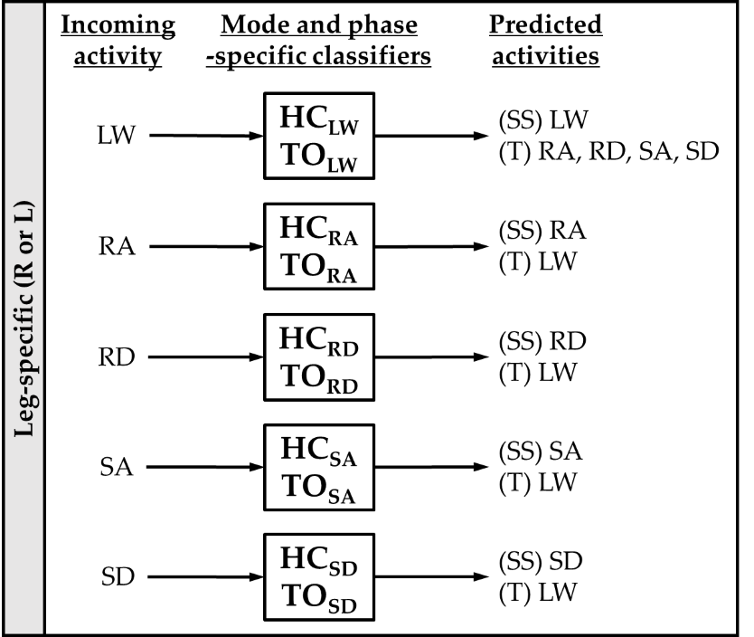

**Supplementary Figure 1.** Mode-specific classification scheme. Ten classifiers were trained for each leg corresponding to all combinations of incoming activity (level walking (LW), ramp ascent (RA), ramp descent (RD), stair ascent (SA), and stair descent (SD)) and gait event (heel contact (HC) and toe off (TO)). The possible predictions for each classifier are listed as steady-state (SS) or transitional (T) activities.

**Supplementary Table 1.** Number of training examples for each mode-specific classifier. The correct labels are listed in the header and instances are aggregated across subjects and between legs.

|  |  |  |  |  |  |  |
| --- | --- | --- | --- | --- | --- | --- |
| **Classifier** | **LW** | **RA** | **RD** | **SA** | **SD** | **Total** |
| **HCLW** | 4523 | 240 | 240 | 239 | 248 | **5490** |
| **TOLW** | 4637 | 245 | 246 | 253 | 243 | **5624** |
| **HCRA** | 243 | 1408 |  |  |  | **1651** |
| **TORA** | 252 | 1416 |  |  |  | **1668** |
| **HCRD** | 239 |  | 1757 |  |  | **1996** |
| **TORD** | 245 |  | 1762 |  |  | **2007** |
| **HCSA** | 238 |  |  | 489 |  | **727** |
| **TOSA** | 245 |  |  | 472 |  | **717** |
| **HCSD** | 248 |  |  |  | 475 | **723** |
| **TOSD** | 242 |  |  |  | 478 | **720** |

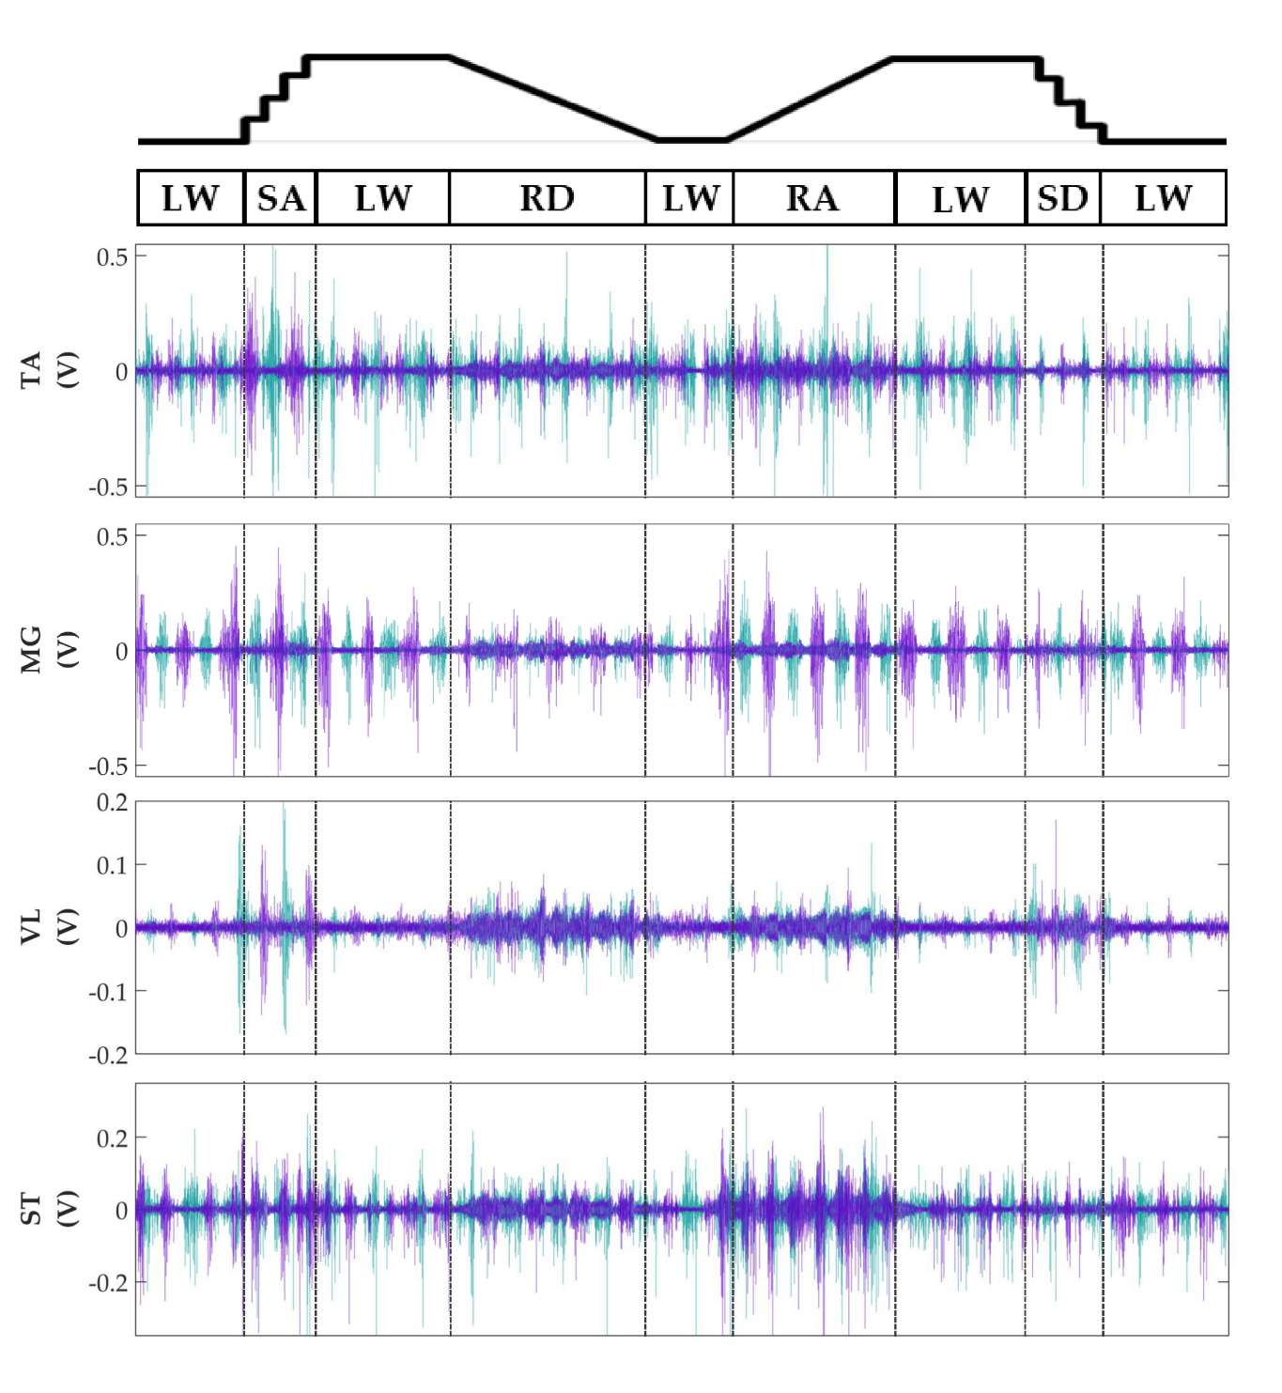

**Supplementary Figure 2. Representative bilateral post-processed EMG signals.** Bilateral filtered EMG (in volts) from upper and lower leg muscles for one subject for a complete circuit consisting of level walking (LW), ramp ascent/descent (RA/RD), and stair ascent/descent (SA/SD). Turquoise traces represent the right leg and purple traces represent the left leg. Circuits were recorded as two discontinuous trials (LW 🡪 SA 🡪 LA 🡪 RD 🡪 LW and LW 🡪 RA 🡪 LW 🡪 SD 🡪 LW) but are represented as continuous.

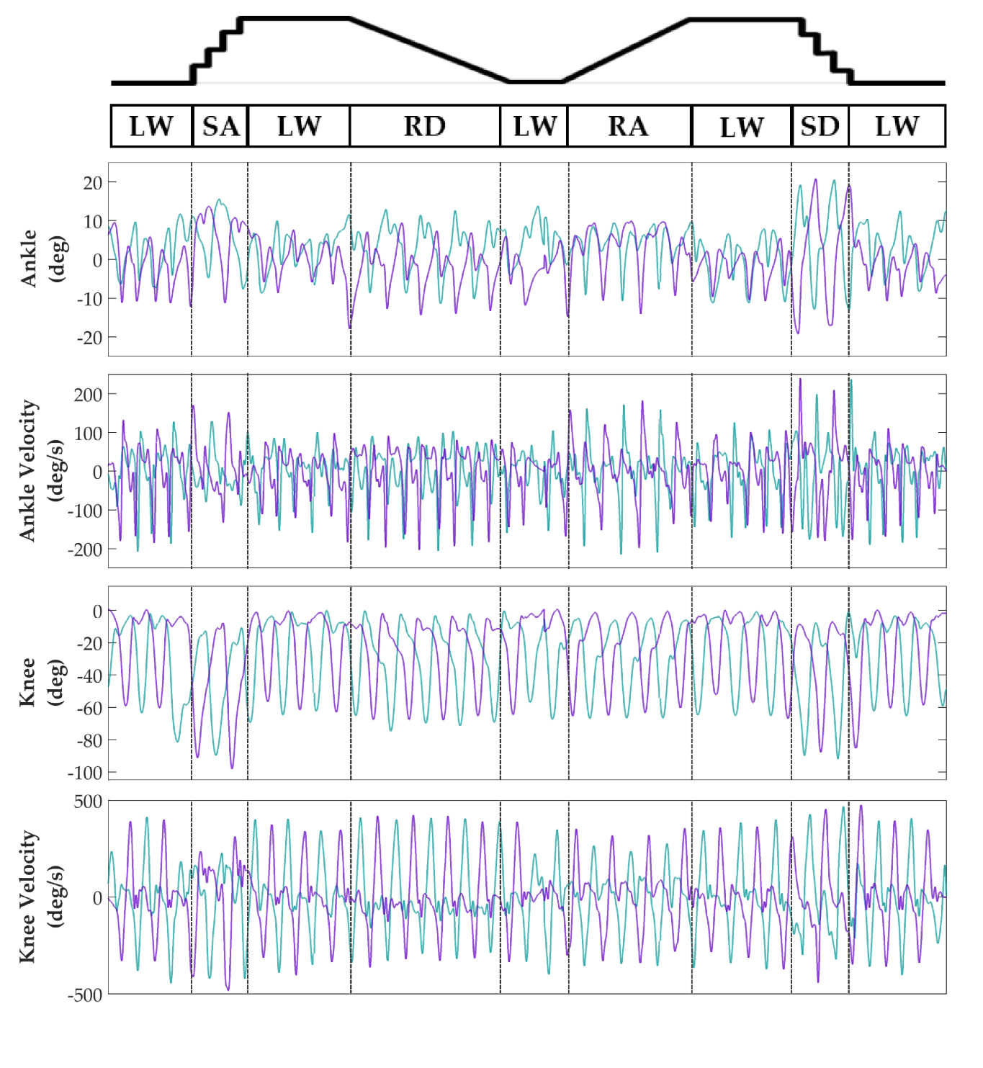

**Supplementary Figure 3. Representative bilateral post-processed joint kinematic signals.** Filtered joint position (and estimated velocities) recorded from knee and ankle goniometers. Turquoise traces represent the right leg and purple traces represent the left leg. Circuits were recorded as two discontinuous trials (LW 🡪 SA 🡪 LA 🡪 RD 🡪 LW and LW 🡪 RA 🡪 LW 🡪 SD 🡪 LW) but are represented as continuous.

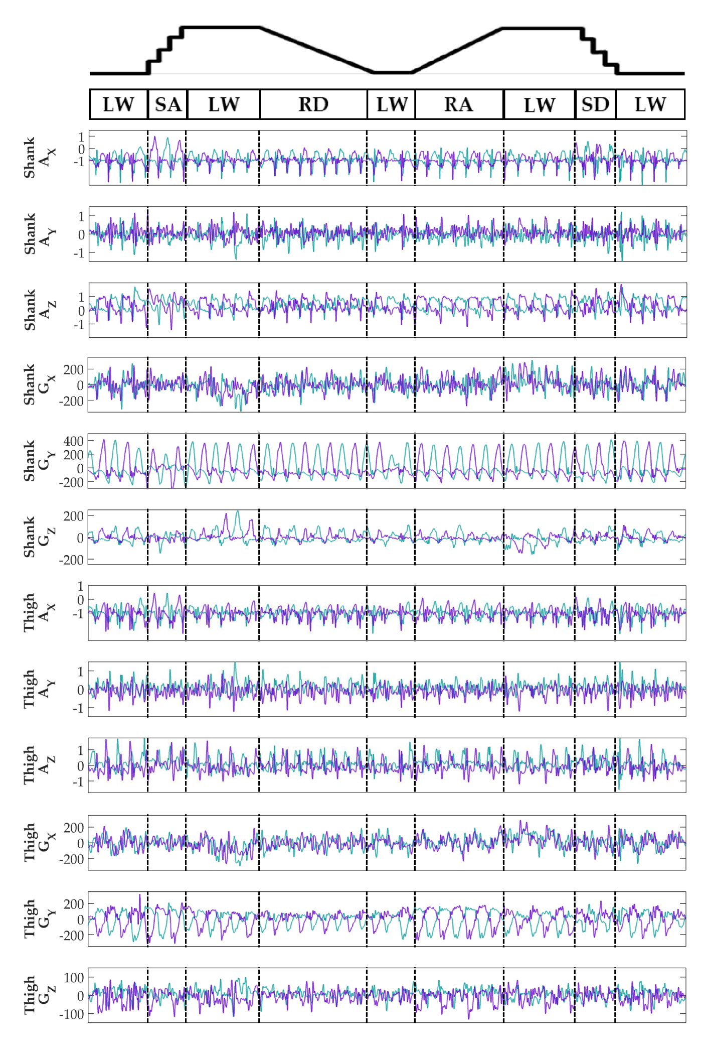

**Supplementary Figure 4. Representative bilateral post-processed limb kinematic signals.** Filtered limb kinematics recorded from shank and thigh IMU’s. Accelerometer (AX, AY, AZ, units in g’s) and gyroscope (GX, GY, GZ­, units in deg/s). Sagittal plane limb movement is represented in GY. Turquoise traces represent the right leg and purple traces represent the left leg. Circuits were recorded as two discontinuous trials (LW 🡪 SA 🡪 LA 🡪 RD 🡪 LW and LW 🡪 RA 🡪 LW 🡪 SD 🡪 LW) but are represented as continuous.

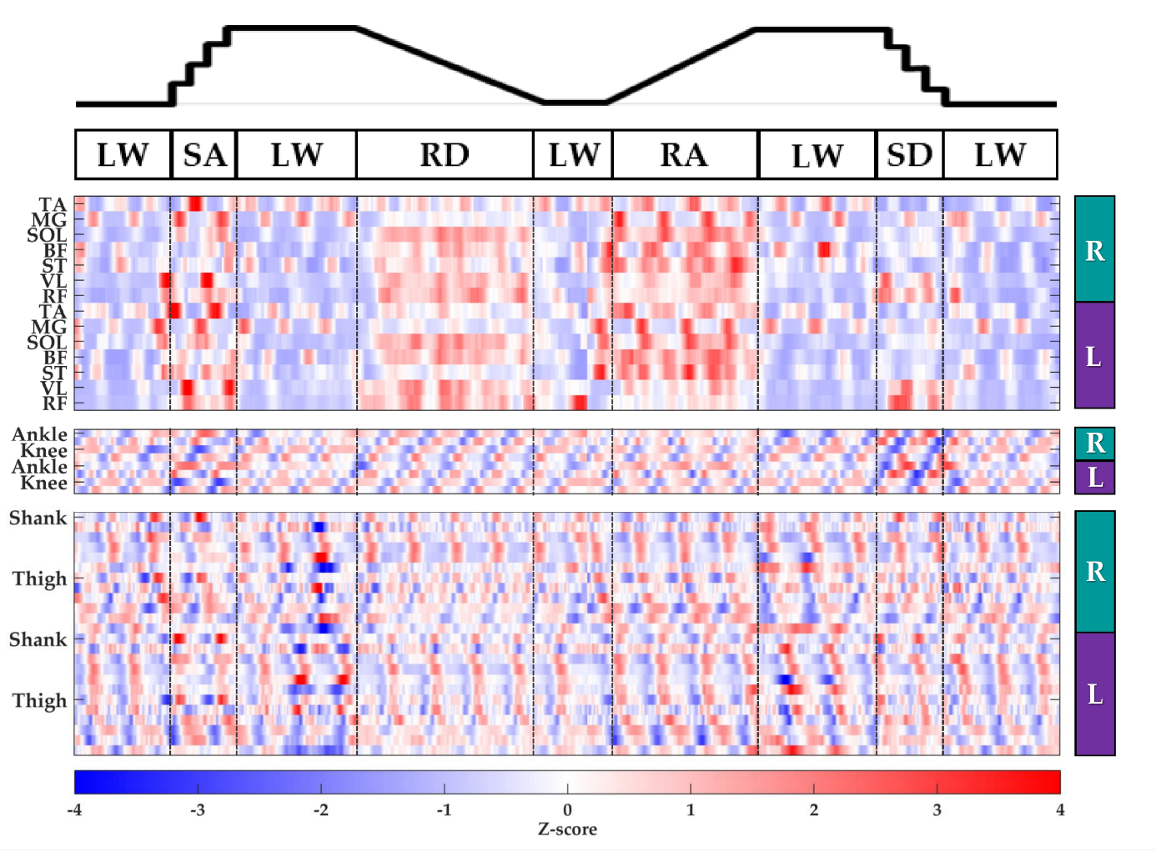

**Supplementary Figure 5. Representative raster plot of bilateral features.** The mean value of each channel (row) for each leg (right, R; left, L) was extracted from sliding windows (length 300 ms, increment 30 ms) for one subject for a complete circuit (same as Supplementary Figures 1-3) consisting of level walking (LW), ramp ascent/descent (RA/RD), and stair ascent/descent (SA/SD). *Z*-scores(represented by the color bar) were computed along each row. Distinct patterns could be visually identified for many additional features (not shown).